ADE Polyscope Viewer Development

Default Settings

Landmark point size
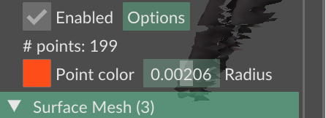

Geo endpoint
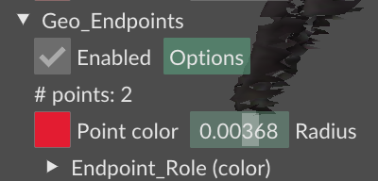

Scan Orientation

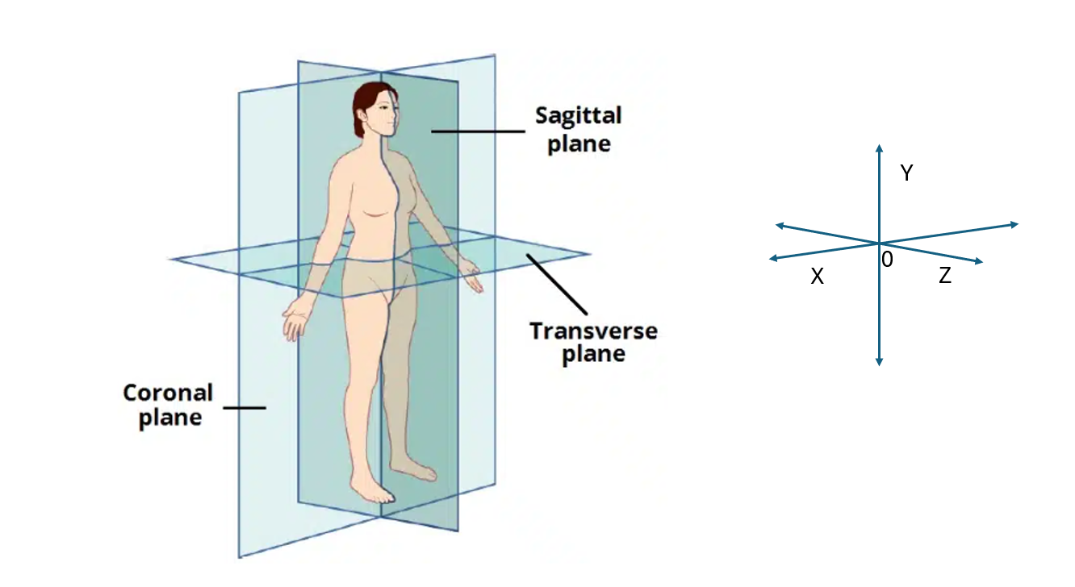
Y = 0 Floor

Landmarking
- Additional Landmark that is the intersection of the side necks and the Front and Back neck.
  - Need to extract Side Neck Left and Right to the point in line with the front neck, same for back neck
  - Use four points of the neck
  - Provide surface lengths in Z as value outputs.
  - Geodesic curve and straight length.

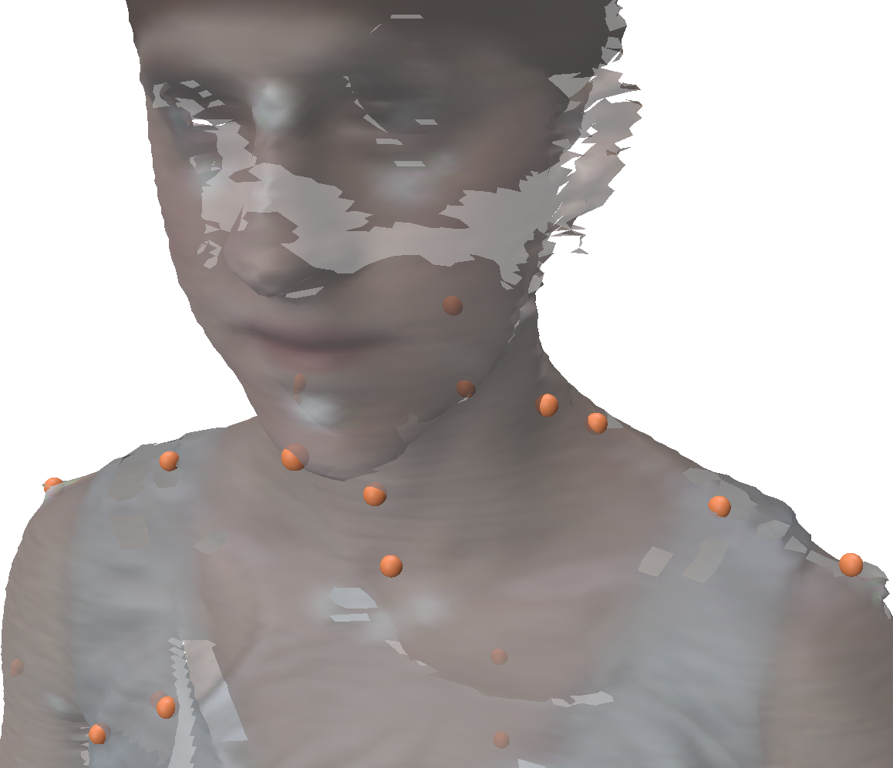

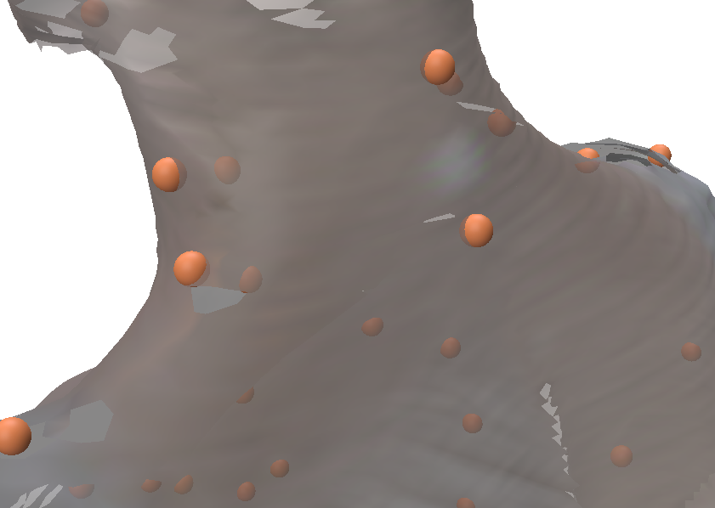

  - Additional Notes V2 and Features:
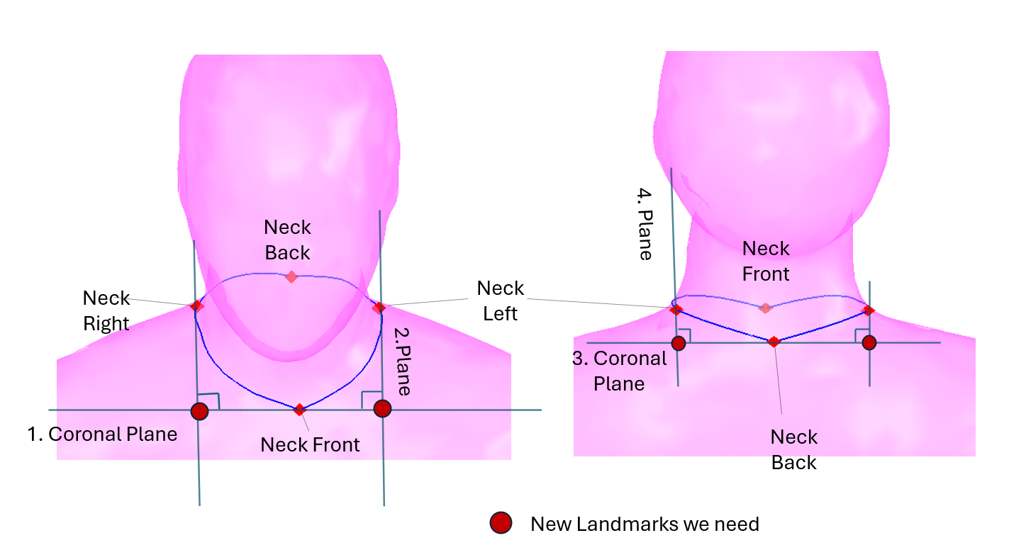
Fig.1.1 [We should use this, initially default o axis of the booth]
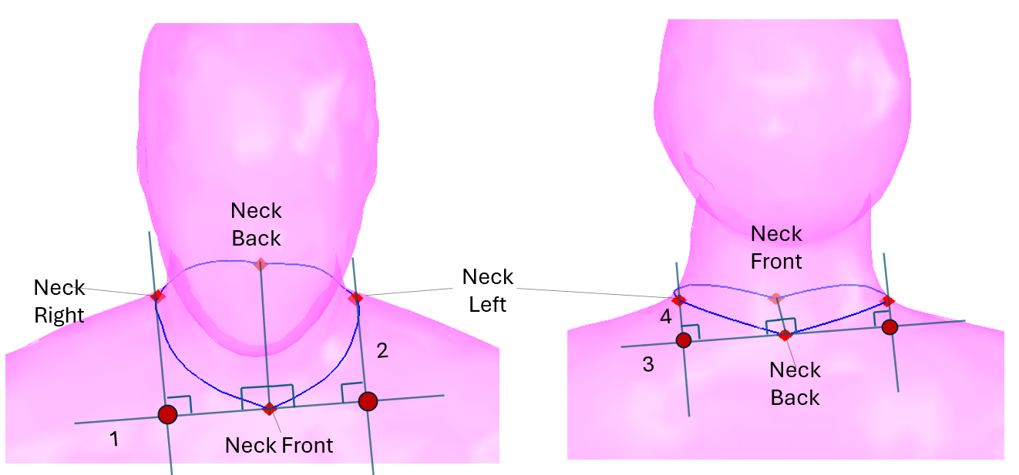
Fig. 1.2 remain question should plane1 and 3 vertical with the Axis-NKFR-NKBK? [We will not use this as it would create difficulties of trying to work out a plane relative to the body]

- Additional landmark 2 – extra waist landmarks
Create four new waist landmarks between four existing waist landmarks at Waist Circumference (transverse plane). And two new bust back dart landmarks at bust circumference (New Landmarks / Existing Landmarks)
  - For anchoring Waist Dart Front Left landmark at waist circumference slice, is captured by the across point by 3 Planes which go through existing landmarks of bust and waist circumference: Plane1: the plane go through Bust Front (Bust with Drop Front) and Bust Left Landmark and vertical to horizontal ground. Plane2: the plane go through Apex Left, vertical to horizontal ground; and vertical with Plane1 on transverse top view. Plane3 anchor Y value: very close or is the transverse plane, which go through each landmark of waist circumference. (Fig. 2b)
For anchoring Waist Dart Front Right landmark at waist circumference slice, is captured by the across point by 3 Planes which go through existing landmarks of bust and waist circumference: Plane1: the plane go through Bust Front (Bust with Drop Front) and Bust Right Landmark and vertical to horizontal ground. Plane2: the plane go through Apex Right, vertical to horizontal ground; and vertical with Plane1 on transverse top view. Plane3 anchor Y value: very close or is the transverse plane, which go through each landmark of waist circumference.
  - For anchoring Waist Dart Back Left, the Arc length from Waist Back to Waist Dart Back Left _{(B)} at waist circumference slice always requires = 50%* Waist Back to Waist Left, across different bodies (Fig.2b).
For anchoring Waist Dart Back Right, the Arc length from Waist Back to Waist Dart Back Right at waist circumference slice always requires= 50%* Waist Back to Waist Right, across different bodies.

  - For anchoring Waist Dart Back Left _{at Bust Level}, the Arc length from Bust Back to Bust Dart Back Left _{bust level} at Bust circumference slice always requires = 50%* Bust Back to Bust Left, across different bodies.

For anchoring Waist Dart Back Right _{at Bust Level}, the Arc length from Bust Back to Waist Dart Back Right _{bust level} at bust circumference slice always requires= 50%* Bust Back to Bust Right, across different bodies.

  - Provide XYZ Value of the four Waist Dart landmark points as value outputs
  - Provide surface Arc lengths A and B at waist circumference plane as value outputs and that of right.
  - Provide surface Arcs length from New Bust Front to Apex Bust Left _{(D)} and Bust Right at bust circumference plane respectively.
  - Provide surface Arcs length from New Bust Front to Bust Left _{(C)} and Apex Bust Right at bust circumference plane respectively.
  - If possible, provide straight connect line length from Apex Bust Left to Waist Dart Front Left and Apex Bust Right to Waist Dart Front Right as value outputs.

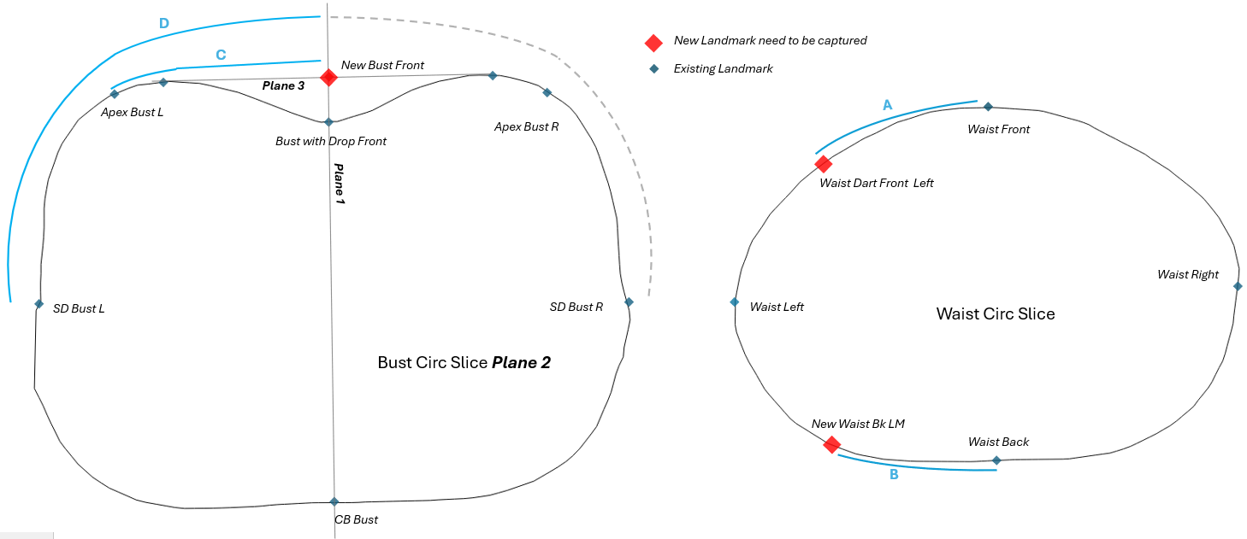Fig.2b
Wais
[Front should keep the waist inline with the bust. Back should use midway of both bust and waist arcs]

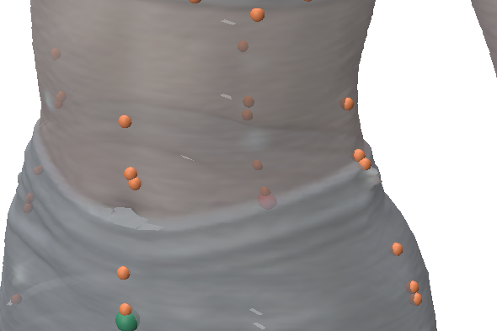
- Extra measurements of the four sections of the upper thigh
a. Provide surface lengths of four segments in horizon (X) as value outputs.
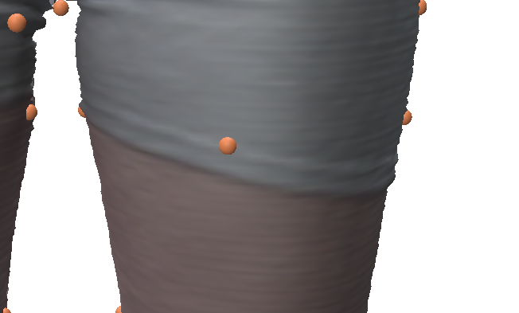
- Measurement outputs into excel, LM outputs x, y, z into excel

- Additional Measurements and Landmarks
5.1 Additional Landmarks – 4 landmarks on left and right Armhole (New Landmarks / Existing Landmarks) Create Armhole Depth Front Point Left/Right and Armhole Depth Back Point Left/Right, if possible.
a. Capture the Armhole Plane Left, the plane go through Shoulder Left and Armpit Left, whiling the plane Z axis always vertical with the X axis (or we call this plane always align the Z axis).
b. Capture the landmark with greatest Z value (Armhole Depth Front Point Left) and the landmark with Lowest Z value on the plane (Armhole Depth Back Point Left) (Fig.5.1)
b. Do same on the body right, if possible.
c. Provide XYZ Value of the four new landmark points as value outputs.
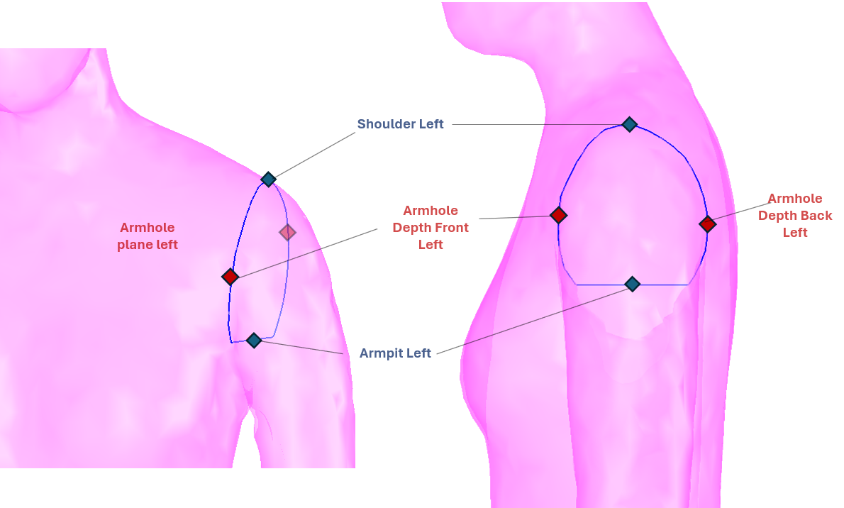
Fig.5.1

5.2 The curve from mid shoulder point to Apex (Left & Right) in vertical as value outputs. (no new landmark requirement)

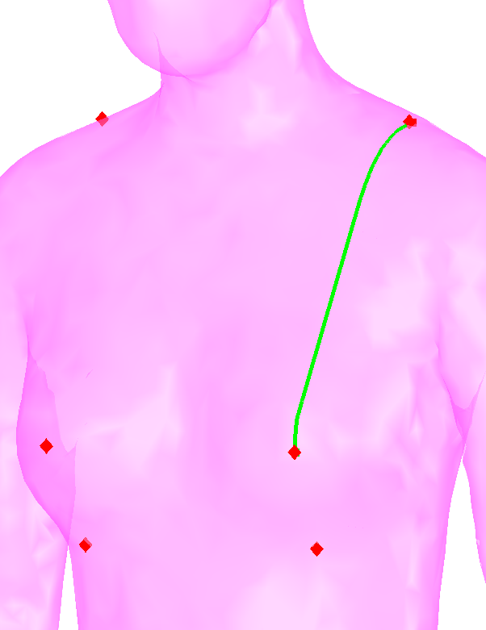
Fig.5.2
5.3 The curve from Apex to Lower Bust Point (Left & Right) in vertical as value outputs. (no new landmark requirement)
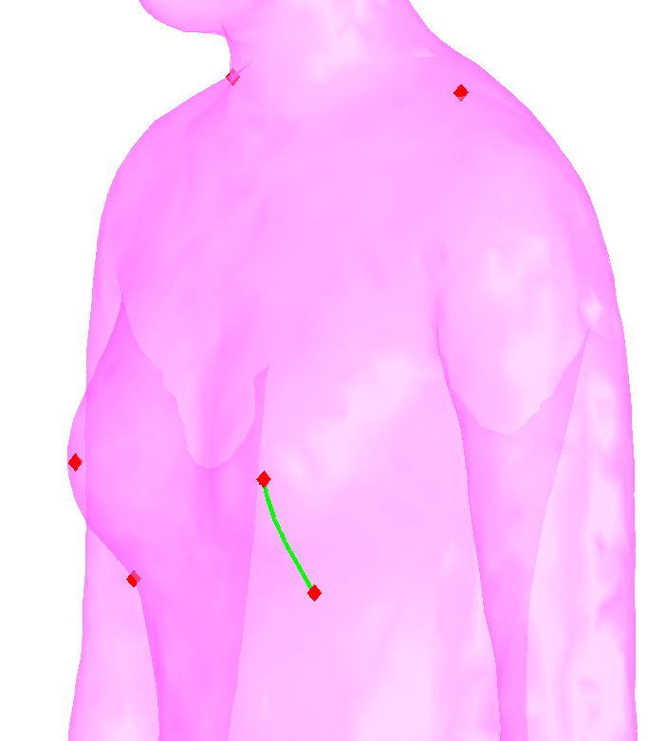
Fig.5.3

Notes:
- Anonymous data
  - Identify the Chain point of face, preserve some feature.

1.2 Copy the code- LM (OBJ) from SS2020 to the MeshLab for modification and adjustment (PyMeshLab).

1.3 SS data to anonymous fold.
2. Coordinate system adjustment
Z (0) point determined by crotch point, remine the X, Y (0). Does X (0) also should reference crotch point?
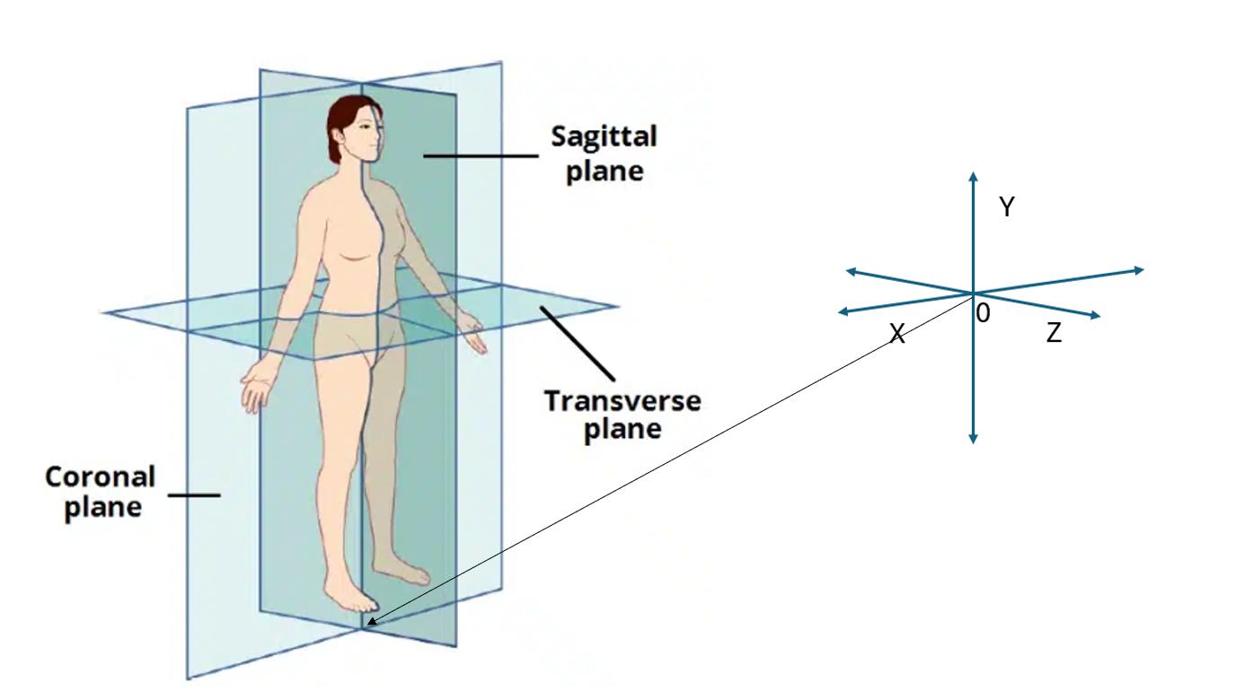

Outputs
Landmarks should be output as x,y,z
Measurements as cm values with a name that relates to the measurement family.

Anonymising the face
Reduce the polygon count in the region of the chin to forehead.
Use py mesh lab
Process is to use the chin (Chin) and forehead (Head Circum Front) to define the region to reduce the polygon count in the face region.

